

**DIGITAL SYSTEM DESIGN APPLICATION – EHB 436E**

**Final Project**

**Muhammed Velihan Bağcı**

**040170093**

**Yiğit Bektaş Gürsoy**

**040180063**

**Class Lecturer: Sıddıka Berna Örs Yalçın**

**Class Assistant:  
Serdar Duran  
Yasin Fırat Kula  
Mehmet Onur Demirtürk**

1. **Description of The Problem**

The assignment given in ninova is shown below. A is to take the power of these integers to be 0, 1 , 2 or 3. Force values can be 0.1,2 or 3. The minimum number that can output is 0. It has the value 00 which is undefined. The maximum possible number is 27. To define 27, we need to define a 5-bit result. These will be discussed in more detail in the algorithm section.



1. **ALU (Arithmetic Logic Unit)**

The Arithmetic Logic Unit (ALU) is a digital circuit within a computer's processor that performs arithmetic and logical operations. It is responsible for executing instructions stored in memory. The ALU has two inputs for operands, performs various operations such as addition, bit shifting, and operation and xor operation, and it has a set of status or flag registers that indicate the results of the previous operation. These flags are used by the processor to make decisions and control the flow of the program. An image of the ALU is described below.

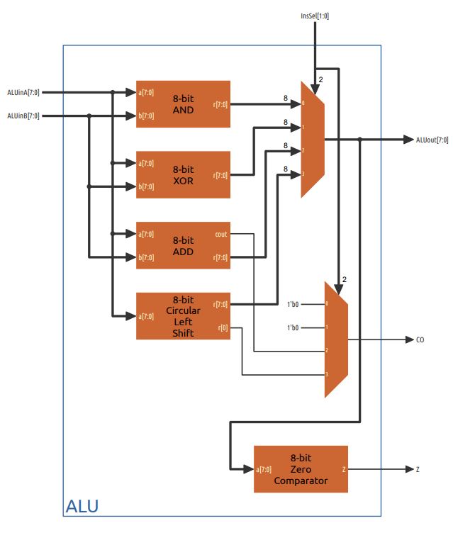

**Verilog Code**

`timescale 1ns **/** 1ps

**module** ALU**(**

**input** **[**7**:**0**]** ALUinA**,** ALUinB**,**

**input** **[**1**:**0**]** InsSel**,**

**output** **[**7**:**0**]** ALUout**,**

**output** CO**,**

**output** Z

**);**

**wire** **[**7**:**0**]** AND_r**,** XOR_r**,** ADD_r**,** CLS_r**,** ALU_r**;**

**wire** ADD_cout**;**

ADD adder **(**

**.**a**(**ALUinA**),**

**.**b**(**ALUinB**),**

**.**r**(**ADD_r**),**

**.**cout**(**ADD_cout**)**

**);**

AND andop **(**

**.**a**(**ALUinA**),**

**.**b**(**ALUinB**),**

**.**r**(**AND_r**)**

**);**

XOR xorop **(**

**.**a**(**ALUinA**),**

**.**b**(**ALUinB**),**

**.**r**(**XOR_r**)**

**);**

Circular_Left_Shift clsop **(**

**.**a**(**ALUinA**),**

**.**r**(**CLS_r**)**

**);**

Zero_Comparator zecoop**(**

**.**a**(**ALU_r**),**

**.**Z**(**Z**)**

**);**

mux_4x1_1bit mux1**(**

**.**a**(**1'b0**),**

**.**b**(**1'b0**),**

**.**c**(**ADD_cout**),**

**.**d**(**CLS_r**[**0**]),**

**.**sel**(**InsSel**),**

**.**z**(**CO**)**

**);**

mux4x1_8bit mux2 **(**

**.**a**(**AND_r**),**

**.**b**(**XOR_r**),**

**.**c**(**ADD_r**),**

**.**d**(**CLS_r**),**

**.**sel**(**InsSel**),**

**.**z**(**ALU_r**)**

**);**

**assign** ALUout **=** ALU_r**;**

**endmodule**

**RTL Schematic**

As seen on the RTL diagram below, we need to use the circular shift operator to get the powers of 2 and 3. Addition block is also defined with XOR and AND gates. Then the zero comperator circuit is defined for the undefined condition. where it is undefined , 00, will result in undefined case. As requested, the blocks here are structurally designed. In this way, it has been seen that the circuit diagram given with RTL Schematic is similar to each other.

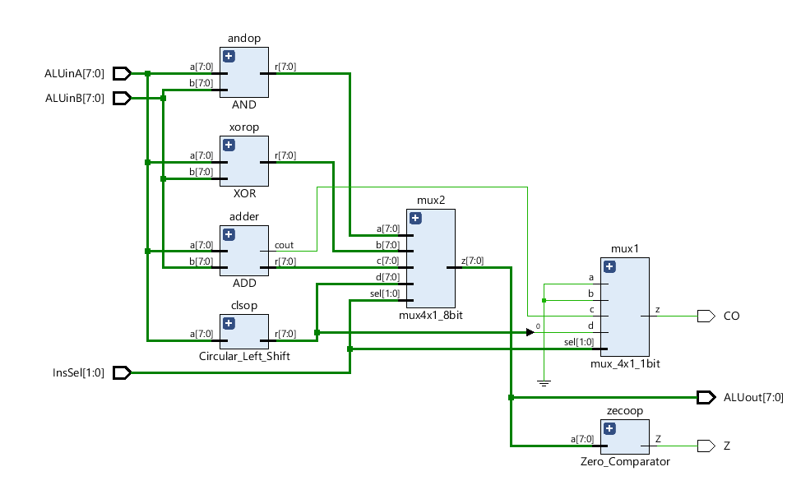

1. **Register Block**

A register block is a crucial component of a computer's processor, it's a group of registers that are used to temporarily store data and instructions during the execution of a program. These registers are small and fast storage locations built into the processor. The number and size of registers in the block can vary depending on the design of the processor, some have a small number of large registers, while others have a large number of smaller ones. The register block also includes a control unit which manages the transfer of data to and from the registers and the ALU, and controls the flow of the program. Below is a representative design of the RB.

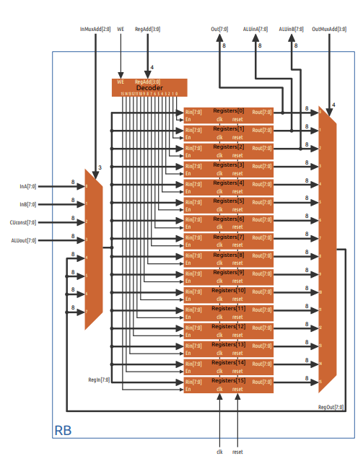

**Verilog Code**

`timescale 1ns **/** 1ps

**module** RB**(**

**input** **[**7**:**0**]** InA**,** InB**,** CUconst**,** ALUout**,**

**input** **[**3**:**0**]** RegAdd**,** OutMuxAdd**,**

**input** **[**2**:**0**]** InMuxAdd**,**

**input** WE**,** clk**,** reset**,**

**output** **[**7**:**0**]** Out**,** ALUinA**,** ALUinB

**);**

**wire** **[**7**:**0**]** RegBlocksOut **[**15**:**0**];**

**wire** **[**15**:**0**]** DecoderOut**;**

**wire** **[**7**:**0**]** RegBlocksIn**,** RegOut**;**

decoder_4x16 decoder1 **(.**sel**(**RegAdd**),** **.**WE**(**WE**),** **.**out**(**DecoderOut**));**

mux_8x1_8bit InMux **(.**a0**(**InA**),** **.**a1**(**InB**),** **.**a2**(**CUconst**),** **.**a3**(**ALUout**),** **.**a4**(**RegOut**),** **.**a5**(**RegOut**),** **.**a6**(**RegOut**),** **.**a7**(**RegOut**),** **.**sel**(**InMuxAdd**),** **.**out**(**RegBlocksIn**));**

Registers reg0 **(.**En**(**DecoderOut**[**0**]),** **.**clk**(**clk**),** **.**reset**(**reset**),** **.**Rin**(**RegBlocksIn**),** **.**Rout**(**RegBlocksOut**[**0**][**7**:**0**]));**

Registers reg1 **(.**En**(**DecoderOut**[**1**]),** **.**clk**(**clk**),** **.**reset**(**reset**),** **.**Rin**(**RegBlocksIn**),** **.**Rout**(**RegBlocksOut**[**1**][**7**:**0**]));**

Registers reg2 **(.**En**(**DecoderOut**[**2**]),** **.**clk**(**clk**),** **.**reset**(**reset**),** **.**Rin**(**RegBlocksIn**),** **.**Rout**(**RegBlocksOut**[**2**][**7**:**0**]));**

Registers reg3 **(.**En**(**DecoderOut**[**3**]),** **.**clk**(**clk**),** **.**reset**(**reset**),** **.**Rin**(**RegBlocksIn**),** **.**Rout**(**RegBlocksOut**[**3**][**7**:**0**]));**

Registers reg4 **(.**En**(**DecoderOut**[**4**]),** **.**clk**(**clk**),** **.**reset**(**reset**),** **.**Rin**(**RegBlocksIn**),** **.**Rout**(**RegBlocksOut**[**4**][**7**:**0**]));**

Registers reg5 **(.**En**(**DecoderOut**[**5**]),** **.**clk**(**clk**),** **.**reset**(**reset**),** **.**Rin**(**RegBlocksIn**),** **.**Rout**(**RegBlocksOut**[**5**][**7**:**0**]));**

Registers reg6 **(.**En**(**DecoderOut**[**6**]),** **.**clk**(**clk**),** **.**reset**(**reset**),** **.**Rin**(**RegBlocksIn**),** **.**Rout**(**RegBlocksOut**[**6**][**7**:**0**]));**

Registers reg7 **(.**En**(**DecoderOut**[**7**]),** **.**clk**(**clk**),** **.**reset**(**reset**),** **.**Rin**(**RegBlocksIn**),** **.**Rout**(**RegBlocksOut**[**7**][**7**:**0**]));**

Registers reg8 **(.**En**(**DecoderOut**[**8**]),** **.**clk**(**clk**),** **.**reset**(**reset**),** **.**Rin**(**RegBlocksIn**),** **.**Rout**(**RegBlocksOut**[**8**][**7**:**0**]));**

Registers reg9 **(.**En**(**DecoderOut**[**9**]),** **.**clk**(**clk**),** **.**reset**(**reset**),** **.**Rin**(**RegBlocksIn**),** **.**Rout**(**RegBlocksOut**[**9**][**7**:**0**]));**

Registers reg10 **(.**En**(**DecoderOut**[**10**]),** **.**clk**(**clk**),** **.**reset**(**reset**),** **.**Rin**(**RegBlocksIn**),** **.**Rout**(**RegBlocksOut**[**10**][**7**:**0**]));**

Registers reg11 **(.**En**(**DecoderOut**[**11**]),** **.**clk**(**clk**),** **.**reset**(**reset**),** **.**Rin**(**RegBlocksIn**),** **.**Rout**(**RegBlocksOut**[**11**][**7**:**0**]));**

Registers reg12 **(.**En**(**DecoderOut**[**12**]),** **.**clk**(**clk**),** **.**reset**(**reset**),** **.**Rin**(**RegBlocksIn**),** **.**Rout**(**RegBlocksOut**[**12**][**7**:**0**]));**

Registers reg13 **(.**En**(**DecoderOut**[**13**]),** **.**clk**(**clk**),** **.**reset**(**reset**),** **.**Rin**(**RegBlocksIn**),** **.**Rout**(**RegBlocksOut**[**13**][**7**:**0**]));**

Registers reg14 **(.**En**(**DecoderOut**[**14**]),** **.**clk**(**clk**),** **.**reset**(**reset**),** **.**Rin**(**RegBlocksIn**),** **.**Rout**(**RegBlocksOut**[**14**][**7**:**0**]));**

Registers reg15 **(.**En**(**DecoderOut**[**15**]),** **.**clk**(**clk**),** **.**reset**(**reset**),** **.**Rin**(**RegBlocksIn**),** **.**Rout**(**RegBlocksOut**[**15**][**7**:**0**]));**

**assign** Out **=** RegBlocksOut**[**0**][**7**:**0**];**

**assign** ALUinA **=** RegBlocksOut**[**1**][**7**:**0**];**

**assign** ALUinB **=** RegBlocksOut**[**2**][**7**:**0**];**

mux_16x1_8bit OutMux**(**

**.**a0**(**RegBlocksOut**[**0**][**7**:**0**]),**

**.**a1**(**RegBlocksOut**[**1**][**7**:**0**]),**

**.**a2**(**RegBlocksOut**[**2**][**7**:**0**]),**

**.**a3**(**RegBlocksOut**[**3**][**7**:**0**]),**

**.**a4**(**RegBlocksOut**[**4**][**7**:**0**]),**

**.**a5**(**RegBlocksOut**[**5**][**7**:**0**]),**

**.**a6**(**RegBlocksOut**[**6**][**7**:**0**]),**

**.**a7**(**RegBlocksOut**[**7**][**7**:**0**]),**

**.**a8**(**RegBlocksOut**[**8**][**7**:**0**]),**

**.**a9**(**RegBlocksOut**[**9**][**7**:**0**]),**

**.**a10**(**RegBlocksOut**[**10**][**7**:**0**]),**

**.**a11**(**RegBlocksOut**[**11**][**7**:**0**]),**

**.**a12**(**RegBlocksOut**[**12**][**7**:**0**]),**

**.**a13**(**RegBlocksOut**[**13**][**7**:**0**]),**

**.**a14**(**RegBlocksOut**[**14**][**7**:**0**]),**

**.**a15**(**RegBlocksOut**[**15**][**7**:**0**]),**

**.**sel**(**OutMuxAdd**),**

**.**out**(**RegOut**)**

**);**

**endmodule**

**RTL Schematic**

As requested, the blocks here are structurally designed. In this way, it has been seen that the circuit diagram given with RTL Schematic is similar to each other.

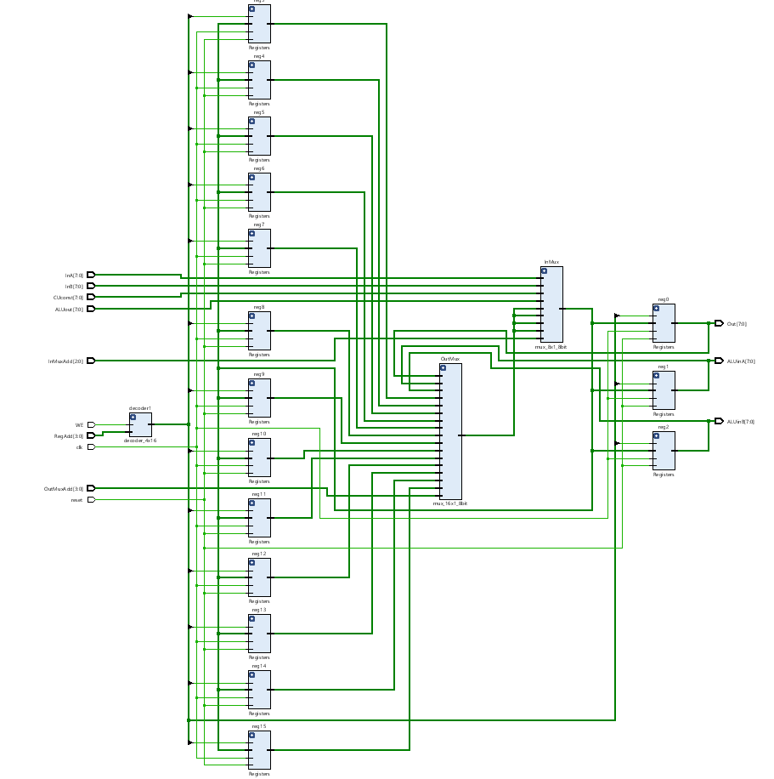

1. **Control Unit**

The control unit (CU) in a computer's processor manages the flow of data and instructions. It retrieves instructions from memory, decodes them to determine the required operation, and then sends control signals to other components such as the ALU and register block to execute the instruction. The CU also updates the program counter to manage the program flow and monitors the processor's status through flags generated by the ALU to make decisions. In summary, the control unit is responsible for coordinating the execution of instructions by decoding them, sending control signals to other components, managing the program flow, and monitoring the processor's status

**ASM Diagram**

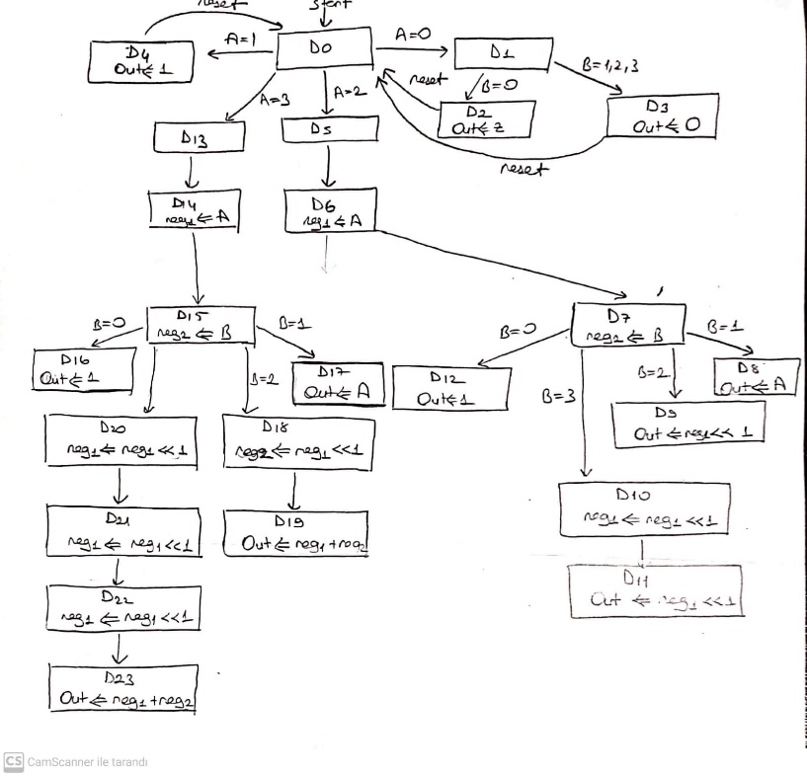

**Verilog Code**

`timescale 1ns **/** 1ps

**module** CU**(**

**input** Start**,** clk**,** reset**,** CO**,** Z**,**

**input** **[**7**:**0**]** InA**,** InB**,**

**output** **reg** Busy**,** WE**,**

**output** **reg** **[**7**:**0**]** CUconst**,**

**output** **reg** **[**3**:**0**]** OutMuxAdd**,** RegAdd**,**

**output** **reg** **[**2**:**0**]** InMuxAdd**,**

**output** **reg** **[**1**:**0**]** InsSel

**);**

**reg** **[**3**:**0**]**durum**;**

**reg** **[**3**:**0**]**durum2**;**

**always@(posedge** clk **or** **posedge** reset**)** **begin**

**if** **(**reset**)** **begin**

InsSel **<=** 0**;**

WE **<=** 0**;**

Busy **<=** 0**;**

CUconst **<=** 0**;**

OutMuxAdd **<=** 0**;**

RegAdd **<=** 0**;**

InMuxAdd **<=**0**;**

durum **<=** 0**;**

durum2 **<=** 0**;**

**end**

**else** **begin**

**if** **(**Start**)** **begin**

Busy **<=**1'b1**;**

durum **<=** 0**;**

durum2 **<=** 0**;**

**end**

**if** **(**Busy **==** 0**)** **begin**

durum **<=** 0**;**

durum2 **<=** 0**;**

**end**

**else** **if** **(**Busy**)** **begin**

**if** **(**InA **==** 8'd0**)begin** // A==0 => sonuç = 0

**if** **(**InB **==** 8'd0**)** **begin**

InMuxAdd **<=**3'd2**;**

CUconst **<=** 8'bzzzz_zzzz**;**

RegAdd **<=** 3'd0**;**

WE **<=** 1'b1**;**

Busy **<=**0**;**

**end**

**else** **begin**

InMuxAdd **<=**3'd0**;**

RegAdd **<=** 3'd0**;**

WE **<=** 1'b1**;**

Busy **<=**0**;**

**end**

**end**

**else** **if** **(**InA **==** 8'd1**)begin** // A==1 => sonuç = 1

InMuxAdd **<=**3'd0**;**

RegAdd **<=** 3'd0**;**

WE **<=** 1'b1**;**

Busy **<=**0**;**

**end**

**else** **if** **(**InA **==** 8'd2**)begin** // A==10 => sonuç = A << B

**if** **(**durum **==** 4'd0**)** **begin** // reg1 <= A

InMuxAdd **<=**3'd0**;**

RegAdd **<=** 3'd1**;**

WE **<=** 1'b1**;**

durum **<=** 4'd1**;**

**end**

**if** **(**durum **==** 4'd1**)** **begin** // reg2 <= B

InMuxAdd **<=**3'd1**;**

RegAdd **<=** 3'd2**;**

WE **<=** 1'b1**;**

durum **<=** 4'd2**;**

**end**

**else** **if** **(**durum **==** 4'd2**)** **begin** // sonuc = A << B

**if(**InB **==** 8'd0**)** **begin** // B==0 => sonuc = 1

InMuxAdd **<=**3'd2**;**

RegAdd **<=** 3'd0**;**

WE **<=** 1'b1**;**

CUconst **<=** 8'd1**;**

Busy **<=** 0**;**

**end**

**else** **if(**InB **==** 8'd1**)** **begin** // B==1 => sonuc = 10

InMuxAdd **<=**3'd0**;**

RegAdd **<=** 3'd0**;**

WE **<=** 1'b1**;**

Busy **<=** 0**;**

**end**

**else** **if(**InB **==** 8'd2**)** **begin** // B==10 => sonuc = 100

InsSel **<=** 2'd3**;**

InMuxAdd **<=** 3'd3**;**

RegAdd **<=** 3'd0**;**

WE **<=** 1'b1**;**

Busy **<=** 0**;**

**end**

**else** **if(**InB **==** 8'd3**)** **begin** // B==11 => sonuc = 1000

**if** **(**durum2 **==** 4'b0**)** **begin** //reg1 <=100

InsSel **<=** 2'd3**;**

InMuxAdd **<=** 3'd3**;**

RegAdd **<=** 3'd1**;**

WE **<=** 1'b1**;**

durum2 **=** 4'b1**;**

**end**

**else** **if** **(**durum2 **==** 4'b1**)** **begin** //sonuc = reg1 << 1;

InsSel **<=** 2'd3**;**

InMuxAdd **<=** 3'd3**;**

RegAdd **<=** 3'd0**;**

WE **<=** 1'b1**;**

Busy **<=** 0**;**

**end**

**end**

**end**

**end**

**else** **if** **(**InA **==** 8'd3**)begin** // A == 11

**if** **(**durum **==** 4'd0**)** **begin** // reg1 <= A

InMuxAdd **<=**3'd0**;**

RegAdd **<=** 3'd1**;**

WE **<=** 1'b1**;**

durum **<=** 4'd1**;**

**end**

**else** **if** **(**durum **==** 4'd1**)** **begin** // reg2 <= B

InMuxAdd **<=**3'd1**;**

RegAdd **<=** 3'd2**;**

WE **<=** 1'b1**;**

durum **<=** 4'd2**;**

**end**

**else** **if** **(**durum **==** 4'd2**)** **begin** // sonuc = A << B

**if(**InB **==** 8'd0**)** **begin** // B==0 => sonuc = 1

InMuxAdd **<=**3'd2**;**

RegAdd **<=** 3'd0**;**

WE **<=** 1'b1**;**

CUconst **<=** 8'd1**;**

Busy **<=** 0**;**

**end**

**else** **if(**InB **==** 8'd1**)** **begin** // B==1 => sonuc = 11

InMuxAdd **<=**3'd0**;**

RegAdd **<=** 3'd0**;**

WE **<=** 1'b1**;**

Busy **<=** 0**;**

**end**

**else** **if(**InB **==** 8'd2**)** **begin** // B==10 => sonuc = 1001

**if** **(**durum2 **==** 4'd0**)** **begin** //reg2 <=110

InsSel **<=** 2'd3**;**

InMuxAdd **<=** 3'd3**;**

RegAdd **<=** 3'd2**;**

WE **<=** 1'b1**;**

durum2 **=** 4'b1**;**

**end**

**else** **if** **(**durum2 **==** 4'd1**)** **begin** //sonuc = reg1 + reg2

InsSel **<=** 2'd2**;**

InMuxAdd **<=** 3'd3**;**

RegAdd **<=** 3'd0**;**

WE **<=** 1'b1**;**

Busy **<=** 0**;**

**end**

**end**

**else** **if(**InB **==** 8'd3**)** **begin** // B==11 => sonuc = 11011

**if** **(**durum2 **==** 4'b0**)** **begin** //reg1 <=110

InsSel **<=** 2'd3**;**

InMuxAdd **<=** 3'd3**;**

RegAdd **<=** 3'd1**;**

WE **<=** 1'b1**;**

durum2 **=** 4'b1**;**

**end**

**else** **if** **(**durum2 **==** 4'b1**)** **begin** //reg1 <=1100

InsSel **<=** 2'd3**;**

InMuxAdd **<=** 3'd3**;**

RegAdd **<=** 3'd1**;**

WE **<=** 1'b1**;**

durum2 **=** 4'd2**;**

**end**

**else** **if** **(**durum2 **==** 4'd2**)** **begin** //reg1 <=11000

InsSel **<=** 2'd3**;**

InMuxAdd **<=** 3'd3**;**

RegAdd **<=** 3'd1**;**

WE **<=** 1'b1**;**

durum2 **=** 4'd3**;**

**end**

**else** **if** **(**durum2 **==** 4'd3**)** **begin** //sonuc = reg1+reg2

InsSel **<=** 2'd2**;**

InMuxAdd **<=** 3'd3**;**

RegAdd **<=** 3'd0**;**

WE **<=** 1'b1**;**

Busy **<=**0**;**

**end**

**end**

**end**

**end**

**end**

**end**

**end**

**endmodule**

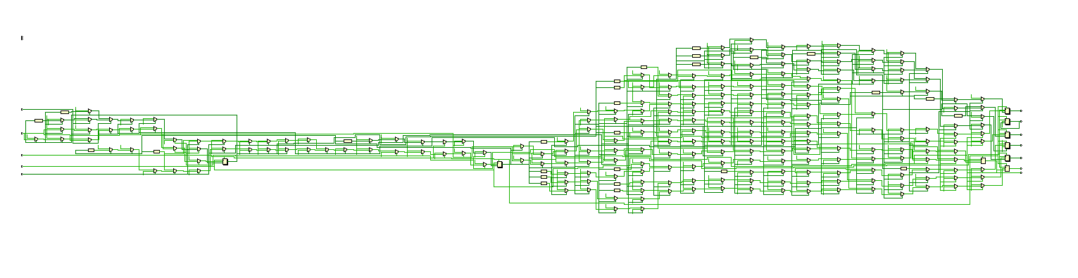**RTL Schematic**

1. **Top Module**

All the blocks described above are connected to this module. As a result of the connected blocks, it has been confirmed by the simulation results that our circuit works correctly. More detailed information is given with the following results.

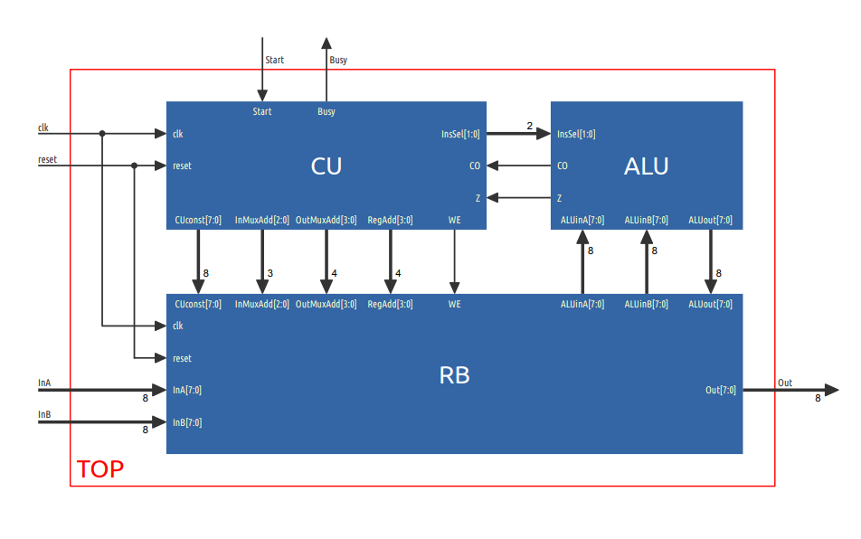

**Verilog Code**

`timescale 1ns **/** 1ps

**module** TOP**(**

**input** clk**,** reset**,** Start**,**

**input** **[**7**:**0**]** InA**,** InB**,**

**output** Busy**,**

**output** **[**7**:**0**]**Out

**);**

**wire** we**,** co**,** z**;**

**wire** **[**1**:**0**]** inssel**;**

**wire** **[**2**:**0**]** inmuxadd**;**

**wire** **[**3**:**0**]** outmuxadd**,** regadd**;**

**wire** **[**7**:**0**]** cuconst**,** aluina**,** aluinb**,** aluout**;**

ALU ArithmeticLogicUnit **(**

**.**InsSel**(**inssel**),**

**.**ALUinA**(**aluina**),**

**.**ALUinB**(**aluinb**),**

**.**Z**(**z**),**

**.**CO**(**co**),**

**.**ALUout**(**aluout**)**

**);**

RB RegistersBlock **(**

**.**clk**(**clk**),**

**.**reset**(**reset**),**

**.**InA**(**InA**),**

**.**InB**(**InB**),**

**.**WE**(**we**),**

**.**CUconst**(**cuconst**),**

**.**InMuxAdd**(**inmuxadd**),**

**.**OutMuxAdd**(**outmuxadd**),**

**.**RegAdd**(**regadd**),**

**.**ALUinA**(**aluina**),**

**.**ALUinB**(**aluinb**),**

**.**ALUout**(**aluout**),**

**.**Out**(**Out**)**

**);**

CU ControlUnit**(**

**.**clk**(**clk**),**

**.**reset**(**reset**),**

**.**Start**(**Start**),**

**.**InA**(**InA**),**

**.**InB**(**InB**),**

**.**CO**(**co**),**

**.**Z**(**z**),**

**.**Busy**(**Busy**),**

**.**CUconst**(**cuconst**),**

**.**InMuxAdd**(**inmuxadd**),**

**.**OutMuxAdd**(**outmuxadd**),**

**.**RegAdd**(**regadd**),**

**.**WE**(**we**),**

**.**InsSel**(**inssel**)**

**);**

**endmodule**

**RTL Schematic**

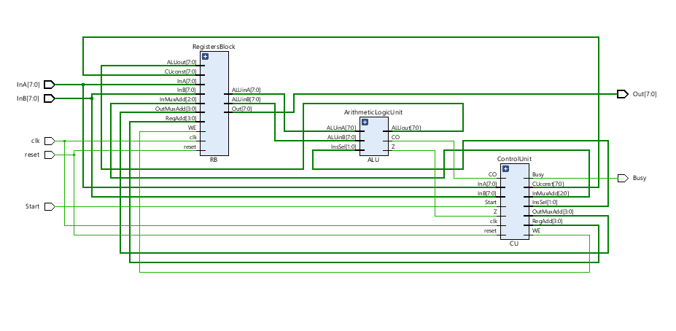As requested, the blocks here are structurally designed. In this way, it has been seen that the circuit diagram given with RTL Schematic is similar to each other.

**Test Bench Code**

`timescale 1ns **/** 1ps

**module** TOP_tb**(** **);**

**reg** clk**,** reset**,** Start**;**

**reg** **[**7**:**0**]** InA**,** InB**;**

**wire** Busy**;**

**wire** **[**7**:**0**]**Out**;**

TOP DUT **(**

**.**clk**(**clk**),**

**.**reset**(**reset**),**

**.**Start**(**Start**),**

**.**InA**(**InA**),**

**.**InB**(**InB**),**

**.**Busy**(**Busy**),**

**.**Out**(**Out**)**

**);**

**always**

**begin**

clk **=** **~**clk**;** **#**10**;**

**end**

**initial** **begin**

clk **=** 0**;** reset **=** 1**;** **#**10**;** reset **=** 0**;**

InA **=** 8'd0**;** InB **=** 8'd0**;** **#**19**;**

Start **=** 1**;** **#**10 Start **=** 0**;** **#**200**;**

reset **=** 1**;** **#**10 reset **=** 0**;**

InA **=** 8'd0**;** InB **=** 8'd1**;** **#**20**;**

Start **=** 1**;** **#**10Start **=** 0**;** **#**200**;**

reset **=** 1**;** **#**10**;** reset **=** 0**;**

InA **=** 8'd0**;** InB **=** 8'd2**;** **#**19**;**

Start **=** 1**;** **#**10 Start **=** 0**;** **#**200**;**

reset **=** 1**;** **#**10 reset **=** 0**;**

InA **=** 8'd0**;** InB **=** 8'd3**;** **#**20**;**

Start **=** 1**;** **#**10Start **=** 0**;** **#**200**;**

reset **=** 1**;** **#**10 reset **=** 0**;**

InA **=** 8'd1**;** InB **=** 8'd0**;** **#**19**;**

Start **=** 1**;** **#**10 Start **=** 0**;** **#**200**;**

reset **=** 1**;** **#**10 reset **=** 0**;**

InA **=** 8'd1**;** InB **=** 8'd1**;** **#**20**;**

Start **=** 1**;** **#**10 Start **=** 0**;** **#**200

reset **=** 1**;** **#**10**;** reset **=** 0**;**

InA **=** 8'd1**;** InB **=** 8'd2**;** **#**19**;**

Start **=** 1**;** **#**10 Start **=** 0**;** **#**200

reset **=** 1**;** **#**10 reset **=** 0**;**

InA **=** 8'd1**;** InB **=** 8'd3**;** **#**20**;**

Start **=** 1**;** **#**10 Start **=** 0**;** **#**200

reset **=** 1**;** **#**10 reset **=** 0**;**

InA **=** 8'd2**;** InB **=** 8'd0**;** **#**19**;**

Start **=** 1**;** **#**10 Start **=** 0**;** **#**200

reset **=** 1**;** **#**10 reset **=** 0**;**

InA **=** 8'd2**;** InB **=** 8'd1**;** **#**20**;**

Start **=** 1**;** **#**10 Start **=** 0**;** **#**200

reset **=** 1**;** **#**10**;** reset **=** 0**;**

InA **=** 8'd2**;** InB **=** 8'd2**;** **#**19**;**

Start **=** 1**;** **#**10 Start **=** 0**;** **#**200

reset **=** 1**;** **#**10 reset **=** 0**;**

InA **=** 8'd2**;** InB **=** 8'd3**;** **#**20**;**

Start **=** 1**;** **#**10Start **=** 0**;** **#**200

reset **=** 1**;** **#**10 reset **=** 0**;**

InA **=** 8'd3**;** InB **=** 8'd0**;** **#**19**;**

Start **=** 1**;** **#**10 Start **=** 0**;** **#**200

reset **=** 1**;** **#**10 reset **=** 0**;**

InA **=** 8'd3**;** InB **=** 8'd1**;** **#**20**;**

Start **=** 1**;** **#**10 Start **=** 0**;** **#**200

reset **=** 1**;** **#**10**;** reset **=** 0**;**

InA **=** 8'd3**;** InB **=** 8'd2**;** **#**19**;**

Start **=** 1**;** **#**10 Start **=** 0**;** **#**200

reset **=** 1**;** **#**10 reset **=** 0**;**

InA **=** 8'd3**;** InB **=** 8'd3**;** **#**20**;**

Start **=** 1**;** **#**10Start **=** 0**;** **#**200**;**

**end**

**endmodule**

**Behavioral Simulation Results**

Below are the simulation results of the Top Module. When Reset = 1, all Register Blocks and Control Unit states are reset. In cases where Start = 1, the Busy signal is activated. As long as this signal is active, Control Unit, ALU and Register Block control the situation by transmitting the necessary signals in line with the given inputs. Our outputs appear in the OUT signal. State 0^0 is entered as undefined. All other states are transferred to OUT after 1 clock cycle from the negedge part of the BUSY signal. As seen in the simulation, 16 cases are also specified. The minimum number that can come as a result of exponential numbers is 0 and the maximum number is 27.

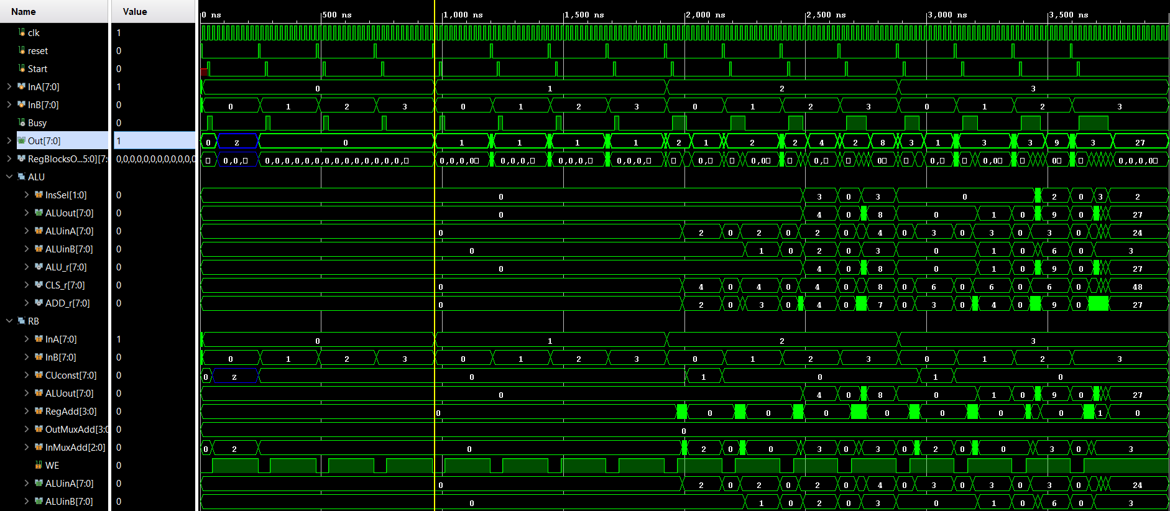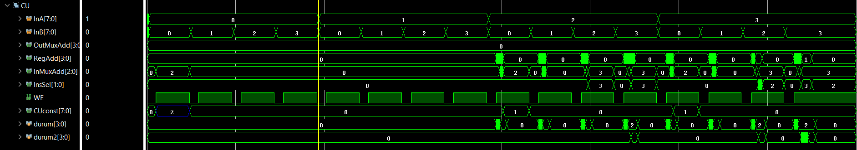

1. **Circuit Analysis Summary ( Top Module )**

**Technology Schematic**

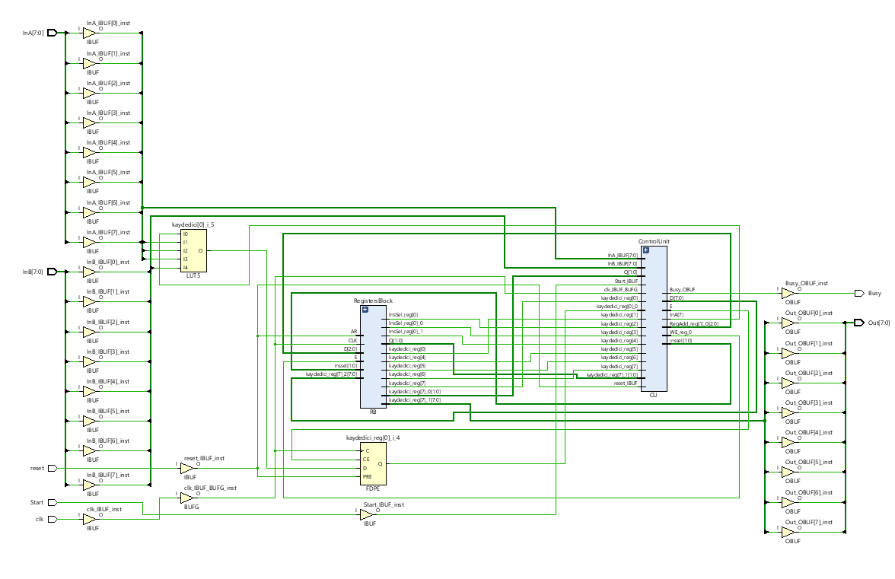

**Setup Delays**

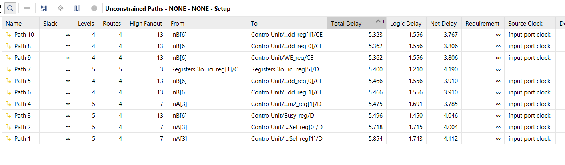

**Hold Delays**

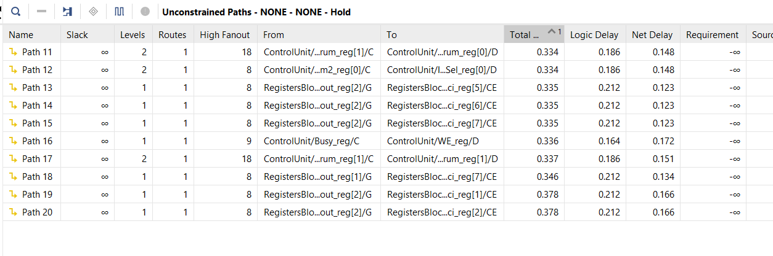

As seen above, the maximum delay of our circuit is 5.854ns. To find the maximum frequency, we find 170.82 Mhz using the equation 1/T = f (hz)

**Utilization Summary**

As seen in the circuit, 65 LUTs, 41 FF’s and 28 IO are used..

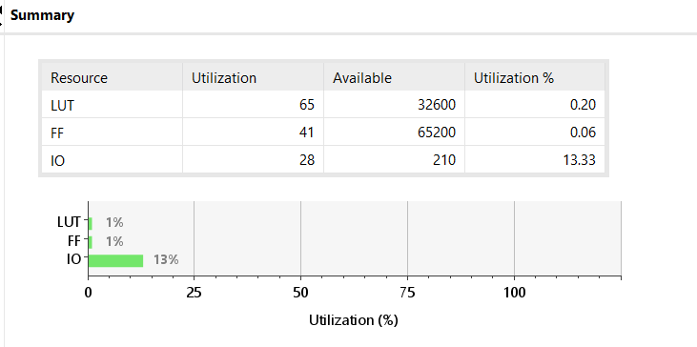

As seen below, the total chip on power value is 0,406W. The individual power consumptions are indicated on the right. Most of the power consumption is Dynamic Power. Although signal and logic consume approximately 55% power, I/O value accounts for all of the power consumption with 45% value.

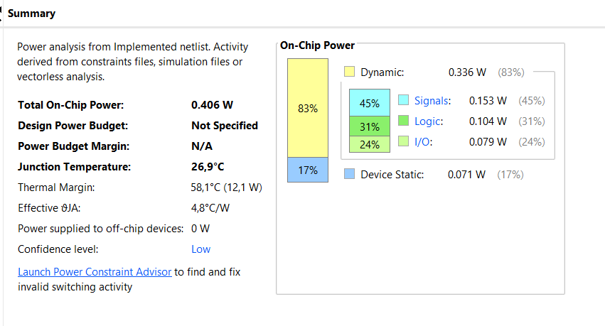

1. **Work Package**

|  |  |  |  |  |  |
| --- | --- | --- | --- | --- | --- |
| **NAME SURNAME** | **Assignment Research** | **Verilog Code** | **ASM Diagram** | **Report** | **Vivado Outputs** |
| **Yiğit Bektaş GÜRSOY** | x | TOP.v  ALU.v  RB.v  CU.v |  | x | x |
| **Muhammed Velihan BAĞCI** | x | TOP.v  ALU.v  RB.v  CU.v | x | x |  |